**VELAMMAL ENGINEERING COLLEGE**

# (An Autonomous Institution)

**CHENNAI–600066**

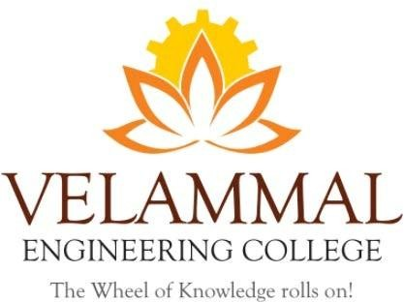

**AI Tools- Innovation and Research**

Organized By

DEPARTMENT OF

PHYSICS

SUBMITTED TO

ENTREPRENEURSHIP DEVELOPMENT CELL LEMON IVY

# VELAMMAL ENGINEERING COLLEGE

**(An Autonomous Institution)**

**Department of Physics**

1. Title of the Event : AI Tools – Innovation and Rsearch (Exclusive for Faculties)
2. Resource Person **: Dr. A. Mohamed Sikkander Abdul Razak**

**Associate Professor & Head**

Department of Chemistry

Velammal Engineering College

3. Date : 09-08-2024

1. Session Type : Offline
2. Program Type : PPT presentation
3. Annexure- I : List of Participants
4. Annexure- II : Broucher,
5. Annexure- III : Photographs

 

|  |  |
| --- | --- |
| **Dr. V. Ramesh Kumar**  Associate Professor  Event Coordinator  Department of Physics | **Dr.S.Shahil Kirupavathy**  Professor & Head  Convener  Department of Physics |

**ANNEXURE-I**

**Table 1: List of Participants**

**List Participant**

|  |  |  |  |
| --- | --- | --- | --- |
| **Sl. No** | **Name** | **Qualification** | **Designation** |
|  | Dr. S. Shahilkirupavathy | [M.Sc., M.Phil., Ph.D](http://m.sc/) | Head and Professor |
|  | Dr. V. Ramesh Kumar | [M.Sc., Ph.D](http://m.sc/) | Associate Professor |
|  | Mrs. G. Hamsavalli | M.Sc., M.Phil., (Ph.D) | Assistant Professor II |
|  | Mr. Moses V.G. Isaiah | M.Sc., M.Phil., (Ph.D) | Assistant Professor I |
|  | Dr. T. A. Revathy | [M.Sc., M.Phil., Ph.D](http://m.sc/) | Assistant Professor |
|  | Dr. J. Arumugam | [M.Sc., M.Phil., Ph.D](http://m.sc/) | Assistant Professor |
|  | Dr. M. Jayachandiran | [M.Sc., Ph.D](http://m.sc/) | Assistant Professor |
|  | Mrs. D. Anitha Jennifer | [M.Sc., M.Phil., (Ph.D](http://m.sc/)) | Assistant Professor |
|  | Mr.V.Baskaran | M.A.,M.Phil | Asst.Professor III &Head |
|  | Ms.S.Sugapriya | M.A.,M.Phil., (Ph.D) | AssistantProfessor |
|  | Mr.A. Balaji | M.A.,M.Phil.      (Ph.D) | AssistantProfessor |
|  | Ms.R. Dhanalakshmi | M.A.,M.Phil., SET | AssistantProfessor |
|  | Ms.J.Latha | M.A.,M.Phil., SET., (Ph.D) | AssistantProfessor |
|  | Dr. M. Vinothkumar | M.A., B.Ed.,M.Phil.,Ph.D | AssistantProfessor |
|  | Mr. V. Anand | M.A., B.Ed., M.Phil., (Ph.D) | AssistantProfessor |
|  | Ms.G.M.Archana | M.A., M.Ed., M.Phil., NET | AssistantProfessor |
|  | Mr. Kirubakaran Amalraj | M.A., B.Ed., M.Phil., SET | AssistantProfessor |

# ANNEXURE –II

**(BROUCHER, REGISTRATION FORM)**



**Figure 1: Poster for AI Tools-Innovation and Research**

Dr. A. Mohamed Sikkander Abdul Razak, Associate Professor and Head of the Department of Chemistry at Velammal Engineering College, presented a lecture on utilizing AI tools effectively for writing research papers. The program was organized by the Department of Physics, with Dr. Shahilkirupavathy serving as the convener and Dr. V. Ramesh Kumar as the event coordinator. Faculty members from both the Physics and English departments attended the meeting, engaging effectively with the invited speaker and seeking clarifications.

**ANNEXURE –III**

**Photographs**

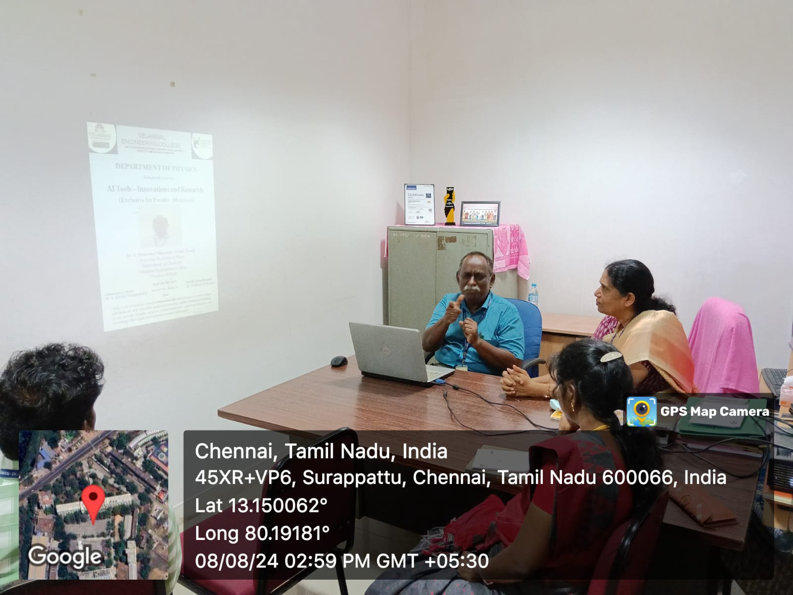

**Figure 2: The invited speaker delivered the speech after being welcomed by Dr.S.Shahilkirupavathy.**

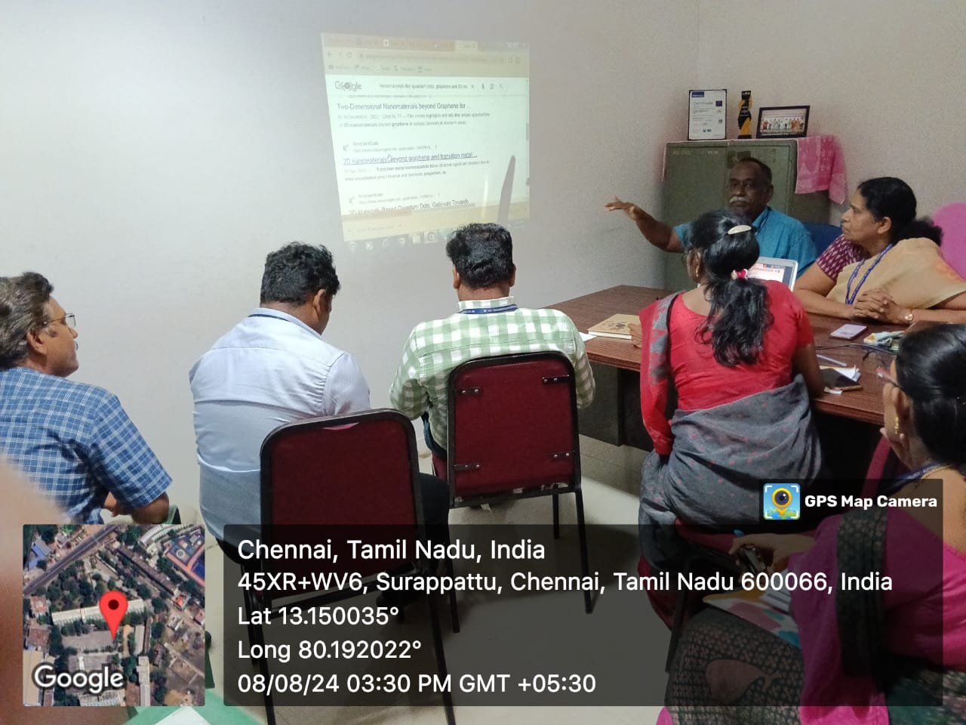

**Figure 3: The speaker has explained about usage of AI Tools for Research.**

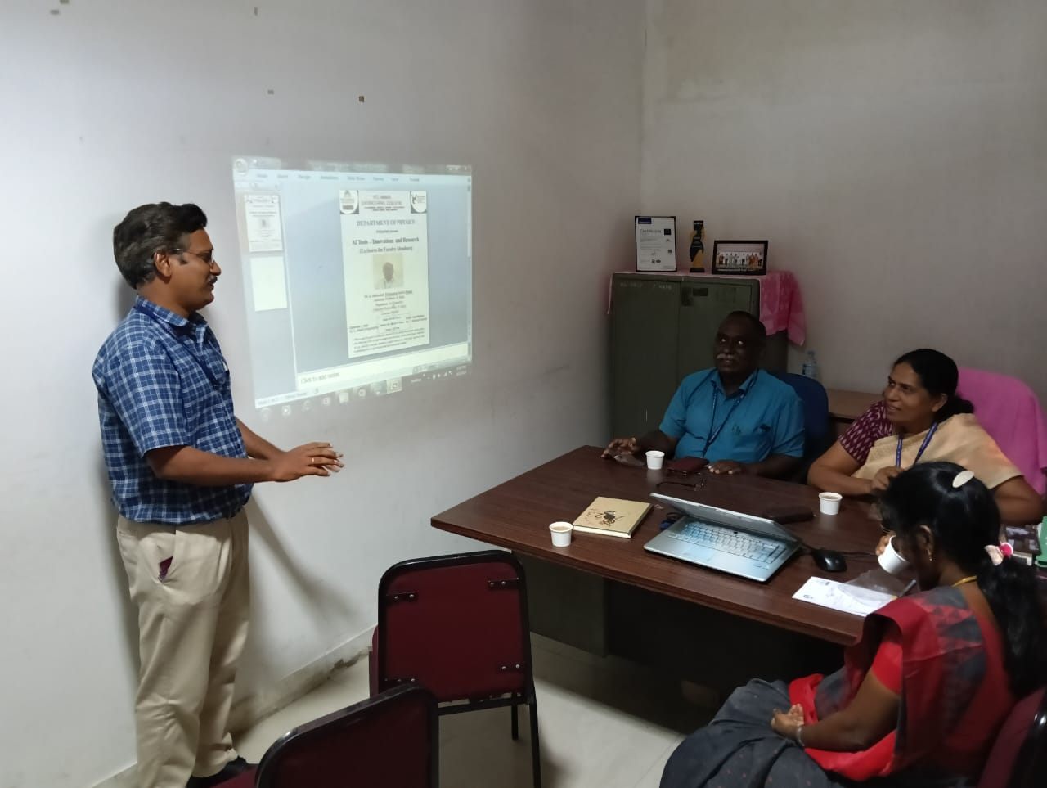

**Figure 4: Vote of Thanks given by event coordinator Dr. V. Ramesh Kumar**